**Note: Margin (Top & Bottom- 1.78 cm; Left & Right- 1.68 cm): Spacing between column- 0.71 cm**

**: Form- Times New Roman: Single spacing: Citation in APA format**

(Gap- single spacing x 2)

Title: Times New Roman; Form size- 20; Capitalize each word; Centre text; Single spacing. For example:

Practicing English Conversation for EFL Students in an Online 3D Virtual World

(Gap- single spacing)

Author: Just authors’ name, no need affiliation or email address; Times New Roman; Form size- 11; Capitalize each word; Centre text; Single spacing. For example:

Rizki Israeni Nur, Haryanto, and Nurdin Noni

(Gap- single spacing)

***Abstract* – Many scholars hold the view that EFL (English as a Foreign Language) … (Bold; Abstractword *Italic* follow by --; Form size- 9; Not more than 300 words; One paragraph)**

(Gap- single spacing)

***Keywords* – 3D virtual world, EFL, English conversation, Text-based chat (Bold; Keywordsword *Italic follow by --*; Form size- 9; At least 4 keywords; Not more than 7 keywords)**

(Gap- single spacing)

(NUMBERING WITH ROMAN NUMERALS; UPPERCASE; FORM SIZE- 10; CENTRE TEXT). FOR EXAMPLE:

1. INTRODUCTION

(Gap- single spacing)

(Content: Indent- 0.5 cm; Times New Roman; Form size- 10; Justify; Single spacing). For example:

We are at present witnessing a rapid increase in the use of English as a language of wider communication (Smith, 2015). However, in many parts of the world, English is still considered as a foreign language (i.e. Panggabean, 2015). In other words, most EFL learners have no chance to be exposed to English culture and they mostly do not use English on a daily basis (Abushihab, 2016).

Fortunately, the development and ubiquity of internet has affected language education. The abundance of resources on internet has brought convenience in language learning (Chen, 2013). Thus, EFL students can easily learn English anywhere and anytime. In recent days, for instance, there are many English platforms available online. Some of them are social network, video messengers, and 3D virtual worlds.

Among other platforms, 3D virtual worlds have special features which unavailable in typical online platforms like social networks or messengers. In this sense, virtual worlds allow participants to interact simultaneously with other

(Gap- single spacing x 2)

(Information of authors; Times New Roman; Form size- 8; Indent- 0.5 cm)

First author, Affiliation (email address).

Second author, Affiliation (email address).

Third author, Affiliation (email address).

Next author, Affiliation (email address).

For example:

Rizki Israeni Nur, University of Malaya, Malaysia (Email address: [rizraeni@gmail.com](mailto:rizraeni@gmail.com)).

players from other countries through representation of avatars (Yeh & Wan, 2016). Thus, it provides a space for English language learners to increase confidence and comfort and to overcome cultural barriers for learning English (Zheng, Young, Brewer, & Wagner, 2009).

In fact, as reported by Lan (2015), many literatures support the use of online virtual world in English education because of its potential of providing EFL learners with the needed language contexts without any temporal barrier as well as the potential of enhancing EFL learners’ language competences.

(Gap- single spacing)

1. PROBLEM STATEMENT

(Gap- single spacing)

Broadly speaking, EFL settings have very limited

opportunities to engage in a real English context (i.e.Marwan, 2007). There are some studies which have discussed the difficulties encountered by EFL learners in practicing English conversation (Hosni, [2014](https://www.researchgate.net/profile/Samira_Al_Hosni/publication/270340628_Speaking_Difficulties_Encountered_by_Young_EFL_Learners/links/54a843470cf256bf8bb7e177/Speaking-Difficulties-Encountered-by-Young-EFL-Learners.pdf)). In Indonesia, for instance, a teacher reported that students readily mock anyone who tries to use English in public (Lamb, 2007).

The reluctance to use English on a daily basis is also found in several non-English-speaking countries. For example, in Turkey, it is found that EFL learners have fear of being negatively evaluated when making mistakes, particularly in front of their friends (Dil, 2009). Likewise, EFL learners in Oman also perceived that making mistakes in front of their classmates is very embarrassing (Al Hosni, [2014](https://www.researchgate.net/profile/Samira_Al_Hosni/publication/270340628_Speaking_Difficulties_Encountered_by_Young_EFL_Learners/links/54a843470cf256bf8bb7e177/Speaking-Difficulties-Encountered-by-Young-EFL-Learners.pdf)). Consequently many EFL learners are afraid to use English in a real context (Lamb, 2007).

(Gap- single spacing)

1. LITERATURE REVIEW

(Gap- single spacing)

***(If you have sub-topic: Times New Roman; Form size- 10; Bold; Italic; Align text left; Single spacing). For example:***

***Online Platforms***

(Gap- single spacing)

Technology has brought a drastic change in the world and has revolutionized education. With a range of possible solutions to develop EFL learning, technology has becoming a successful medium for practicing English conversation. Additionally, technology is also able to present authentic situations where learners unable to see in real life situations (Diyyab, 2014). With the massive growth of online conversation platforms, it becomes easier for language learners to practice English with people from other countries.

In terms of online conversation platforms, Wakefield & Rice (2008) point out that text messaging, instant messaging, chat rooms, and personal web sites have increased the speed of multiple and simultaneous interaction. Based on this fact, it is indispensable to take advantage of modern technological facilities in aiding the task of English language practices (Hwang, Huang, Shadiev, Wu, & Chen, 2014). This technology provides many new potential channels for promoting English conversation among people who live in different countries (Wu, Yen & Marek, 2011). Among online conversation platforms, there is one type of platforms that replicates a real world situation, which known as 3D Virtual Worlds.

…

(Gap- single spacing)

(If you have figure: Label below figure; Times New Roman; Form size- 8; Capitalize Each Word; Centre text; Numbering by number). For example:

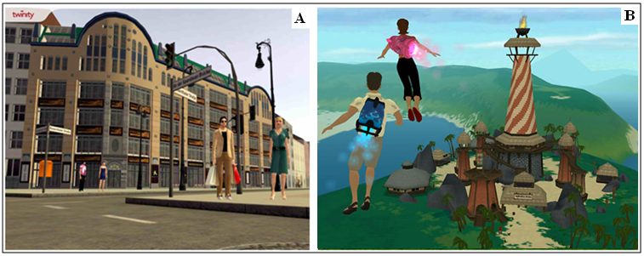Figure 1. There 3D Virtual Worlds

(Gap- single spacing)

1. METHOD

(Gap- single spacing)

(If you have table: Label above table: Times New Roman; Form size- 8 for table label and table content; UPPERCAST; Centre text; Numbering by Roman Numerals). For example:

TABLE I: ANALYTIC SCORING RUBRICS FOR CONTENT OF ENGLISH WRITTEN COMMUNICATION

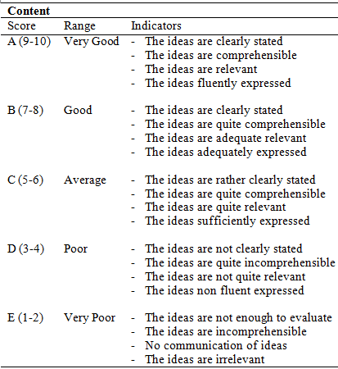

Adapted from Salija (2004)

(Gap- single spacing)

1. FINDINGS

(Gap- single spacing)

...

(Gap- single spacing)

1. DISCUSSION

(Gap- single spacing)

…

(Gap- single spacing)

1. CONCLUSION (OR LIMITATION OR SUGGESTION FOR FURTHER STUDIES)

(Gap- single spacing)

…

(Gap- single spacing)

(IF YOU WANT MENTION FUNDS). FOR EXAMPLE:

ACKNOWLEDGEMENT

(Gap- single spacing)

This work was supported by xxx under xxx

(Gap- single spacing)

REFERENCES

(Gap single spacing)

(Use APA style)

Abushihab, I. (2016). Foreign words in Jordanian Arabic among Jordanians living in Irbid city: The impact of foreign languages on Jordanian Arabic. *Journal of Language Teaching and Research*, 7(2), 284-292.

Al Hosni, S. (2014). Speaking difficulties encountered by young EFL learners. *International Journal on Studies in English Language and Literature* (IJSELL), 2(6), 22-30.